Government College[A] Rajahmundry
Department of Biotechnology
Name of the activity : Best practise
Title : Health camp ( Screening for Diabetes , Blood pressure , Determination of BMI and Blood group )
Date:17/3/26, Day: Tuesday
Venue : Govt college ( A ) Rjy .
Lectures Involved : Dr.B.Nageshwari, Dr.k.Anusha,Mrs .K.Jaswanthi.
Number of students involved : 1st year ,2nd year and final year

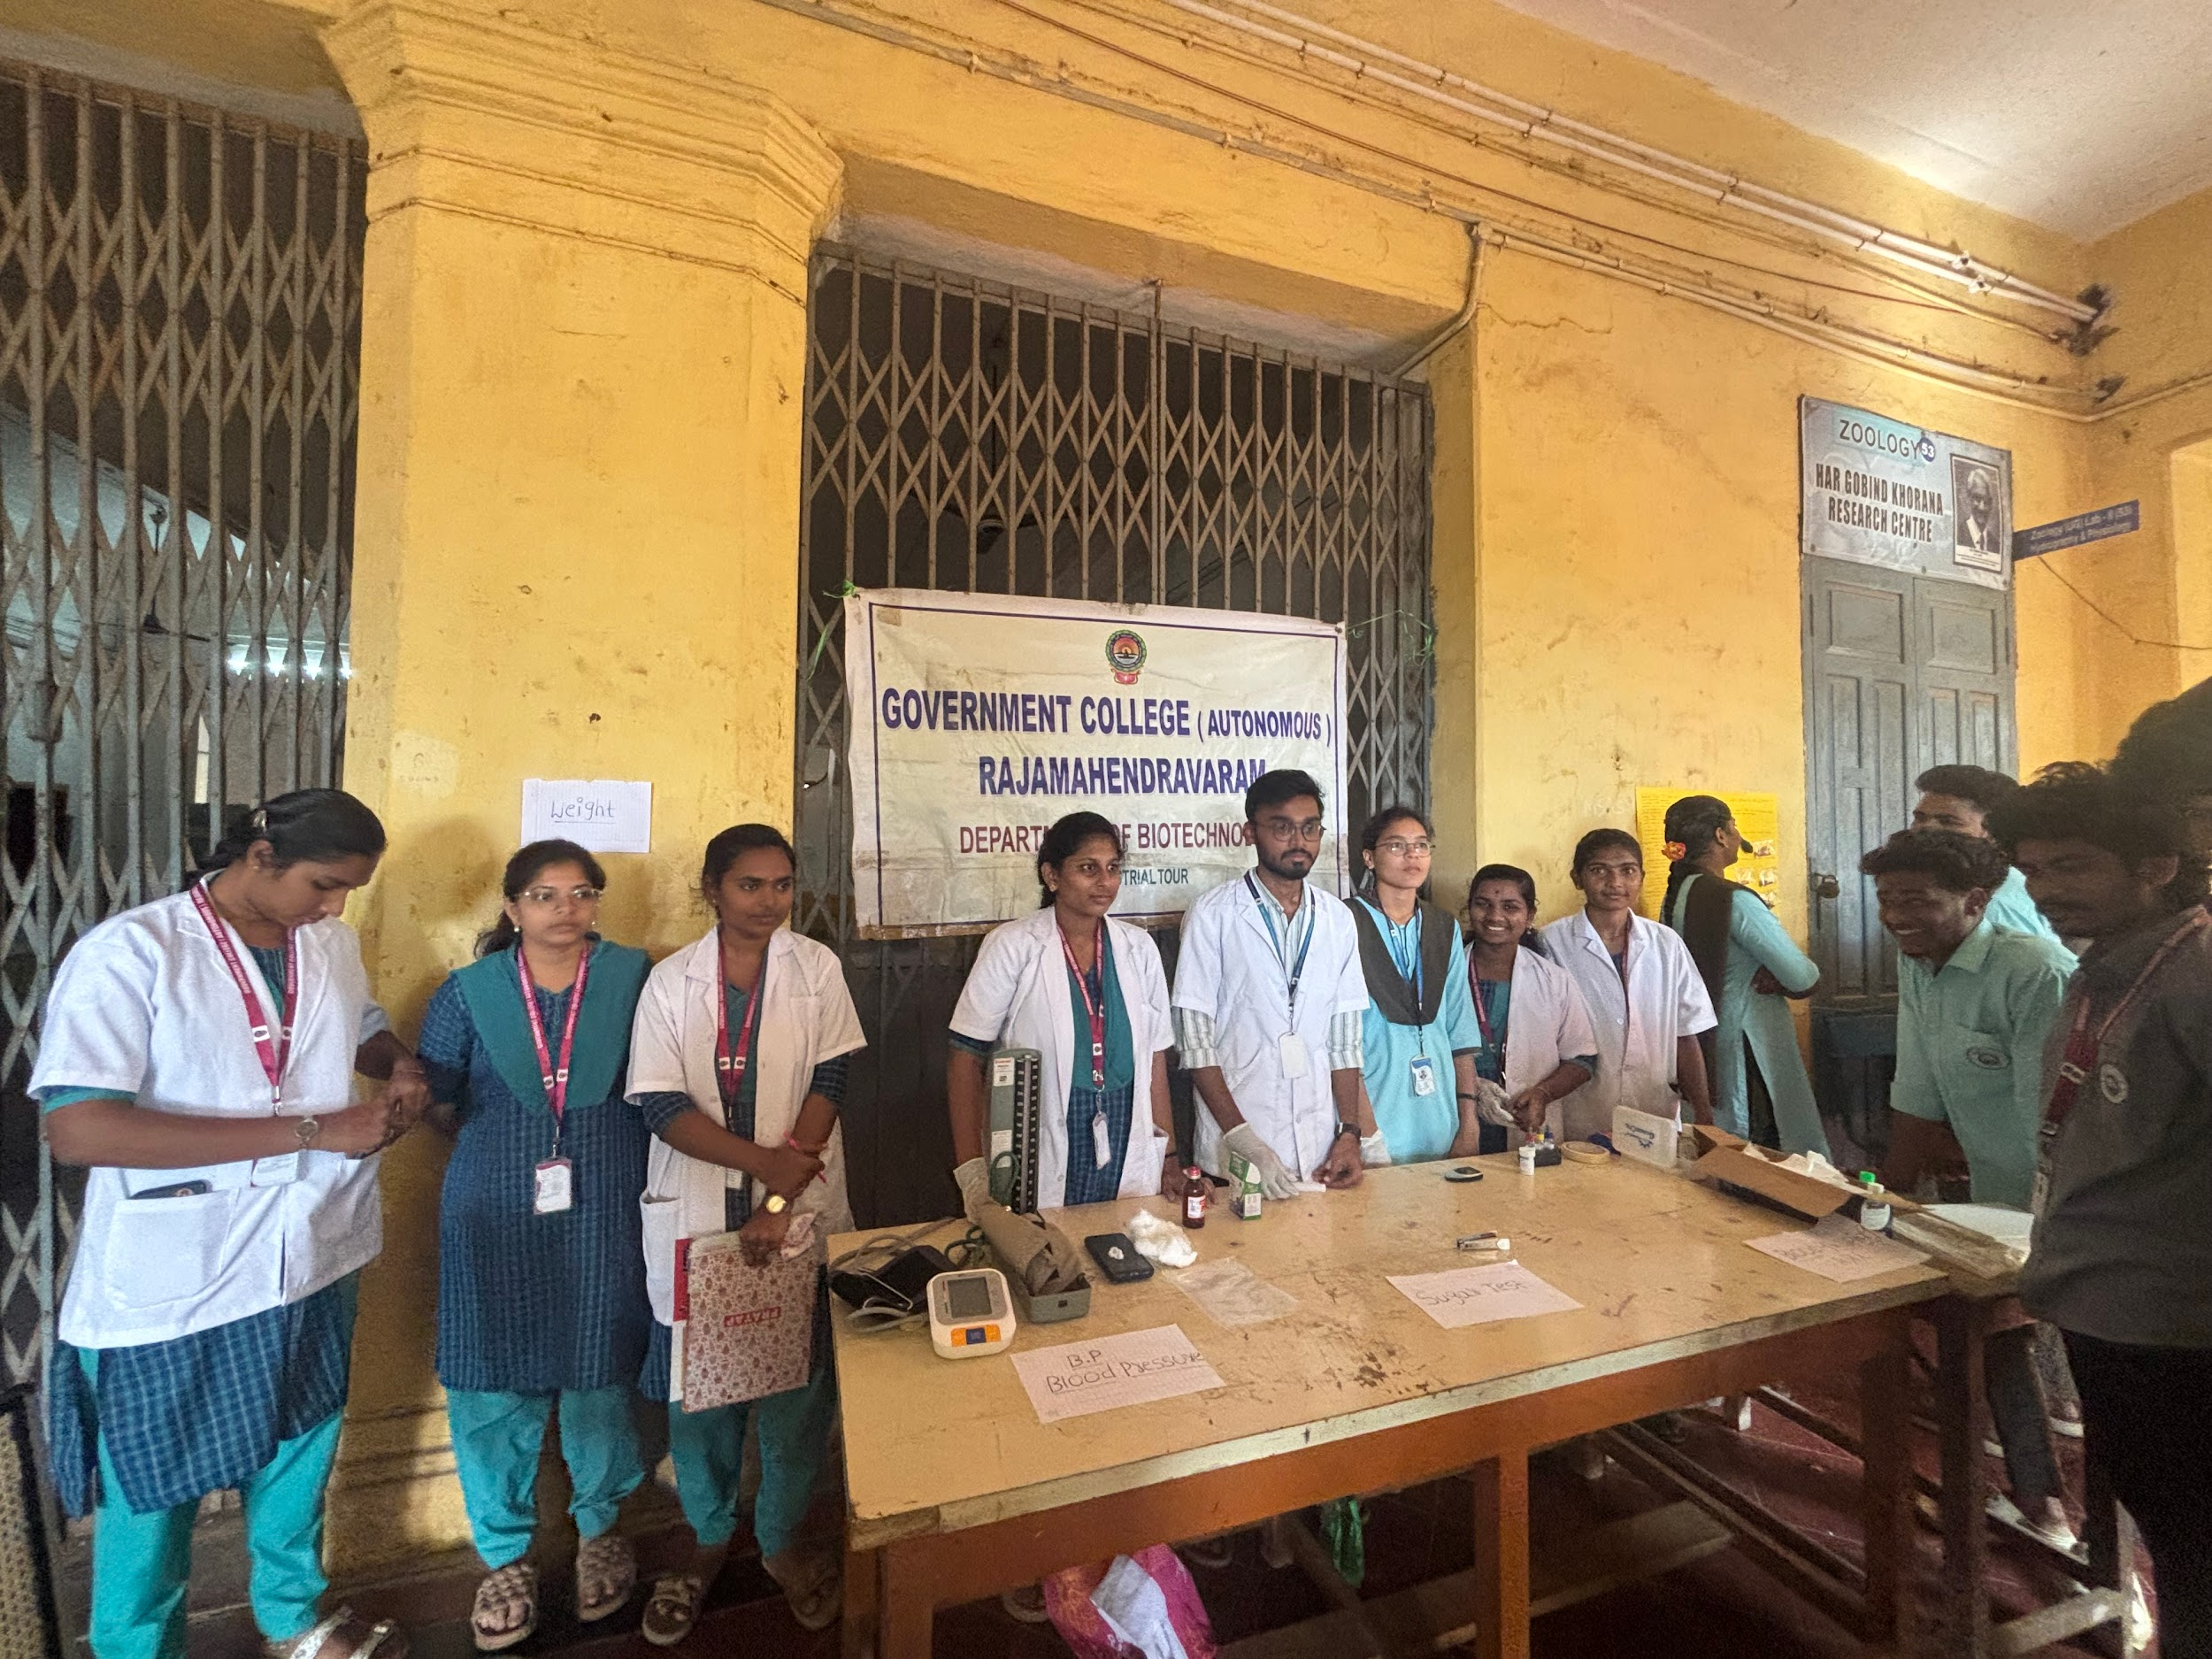
Screening for Blood pressure
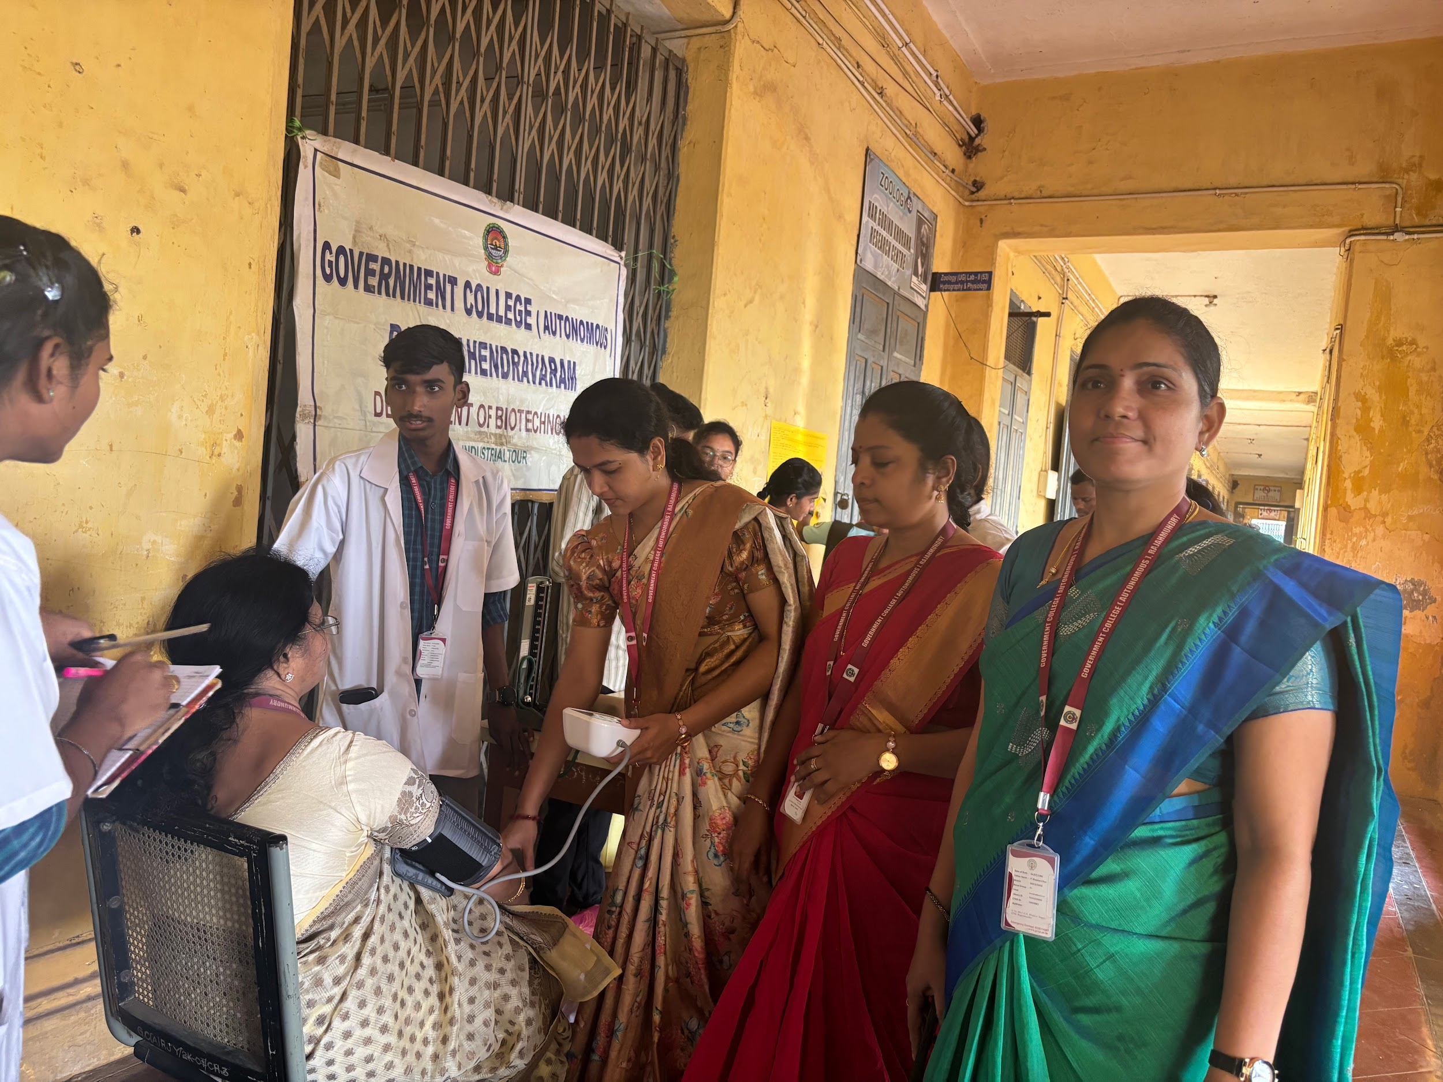
Determination of BMI

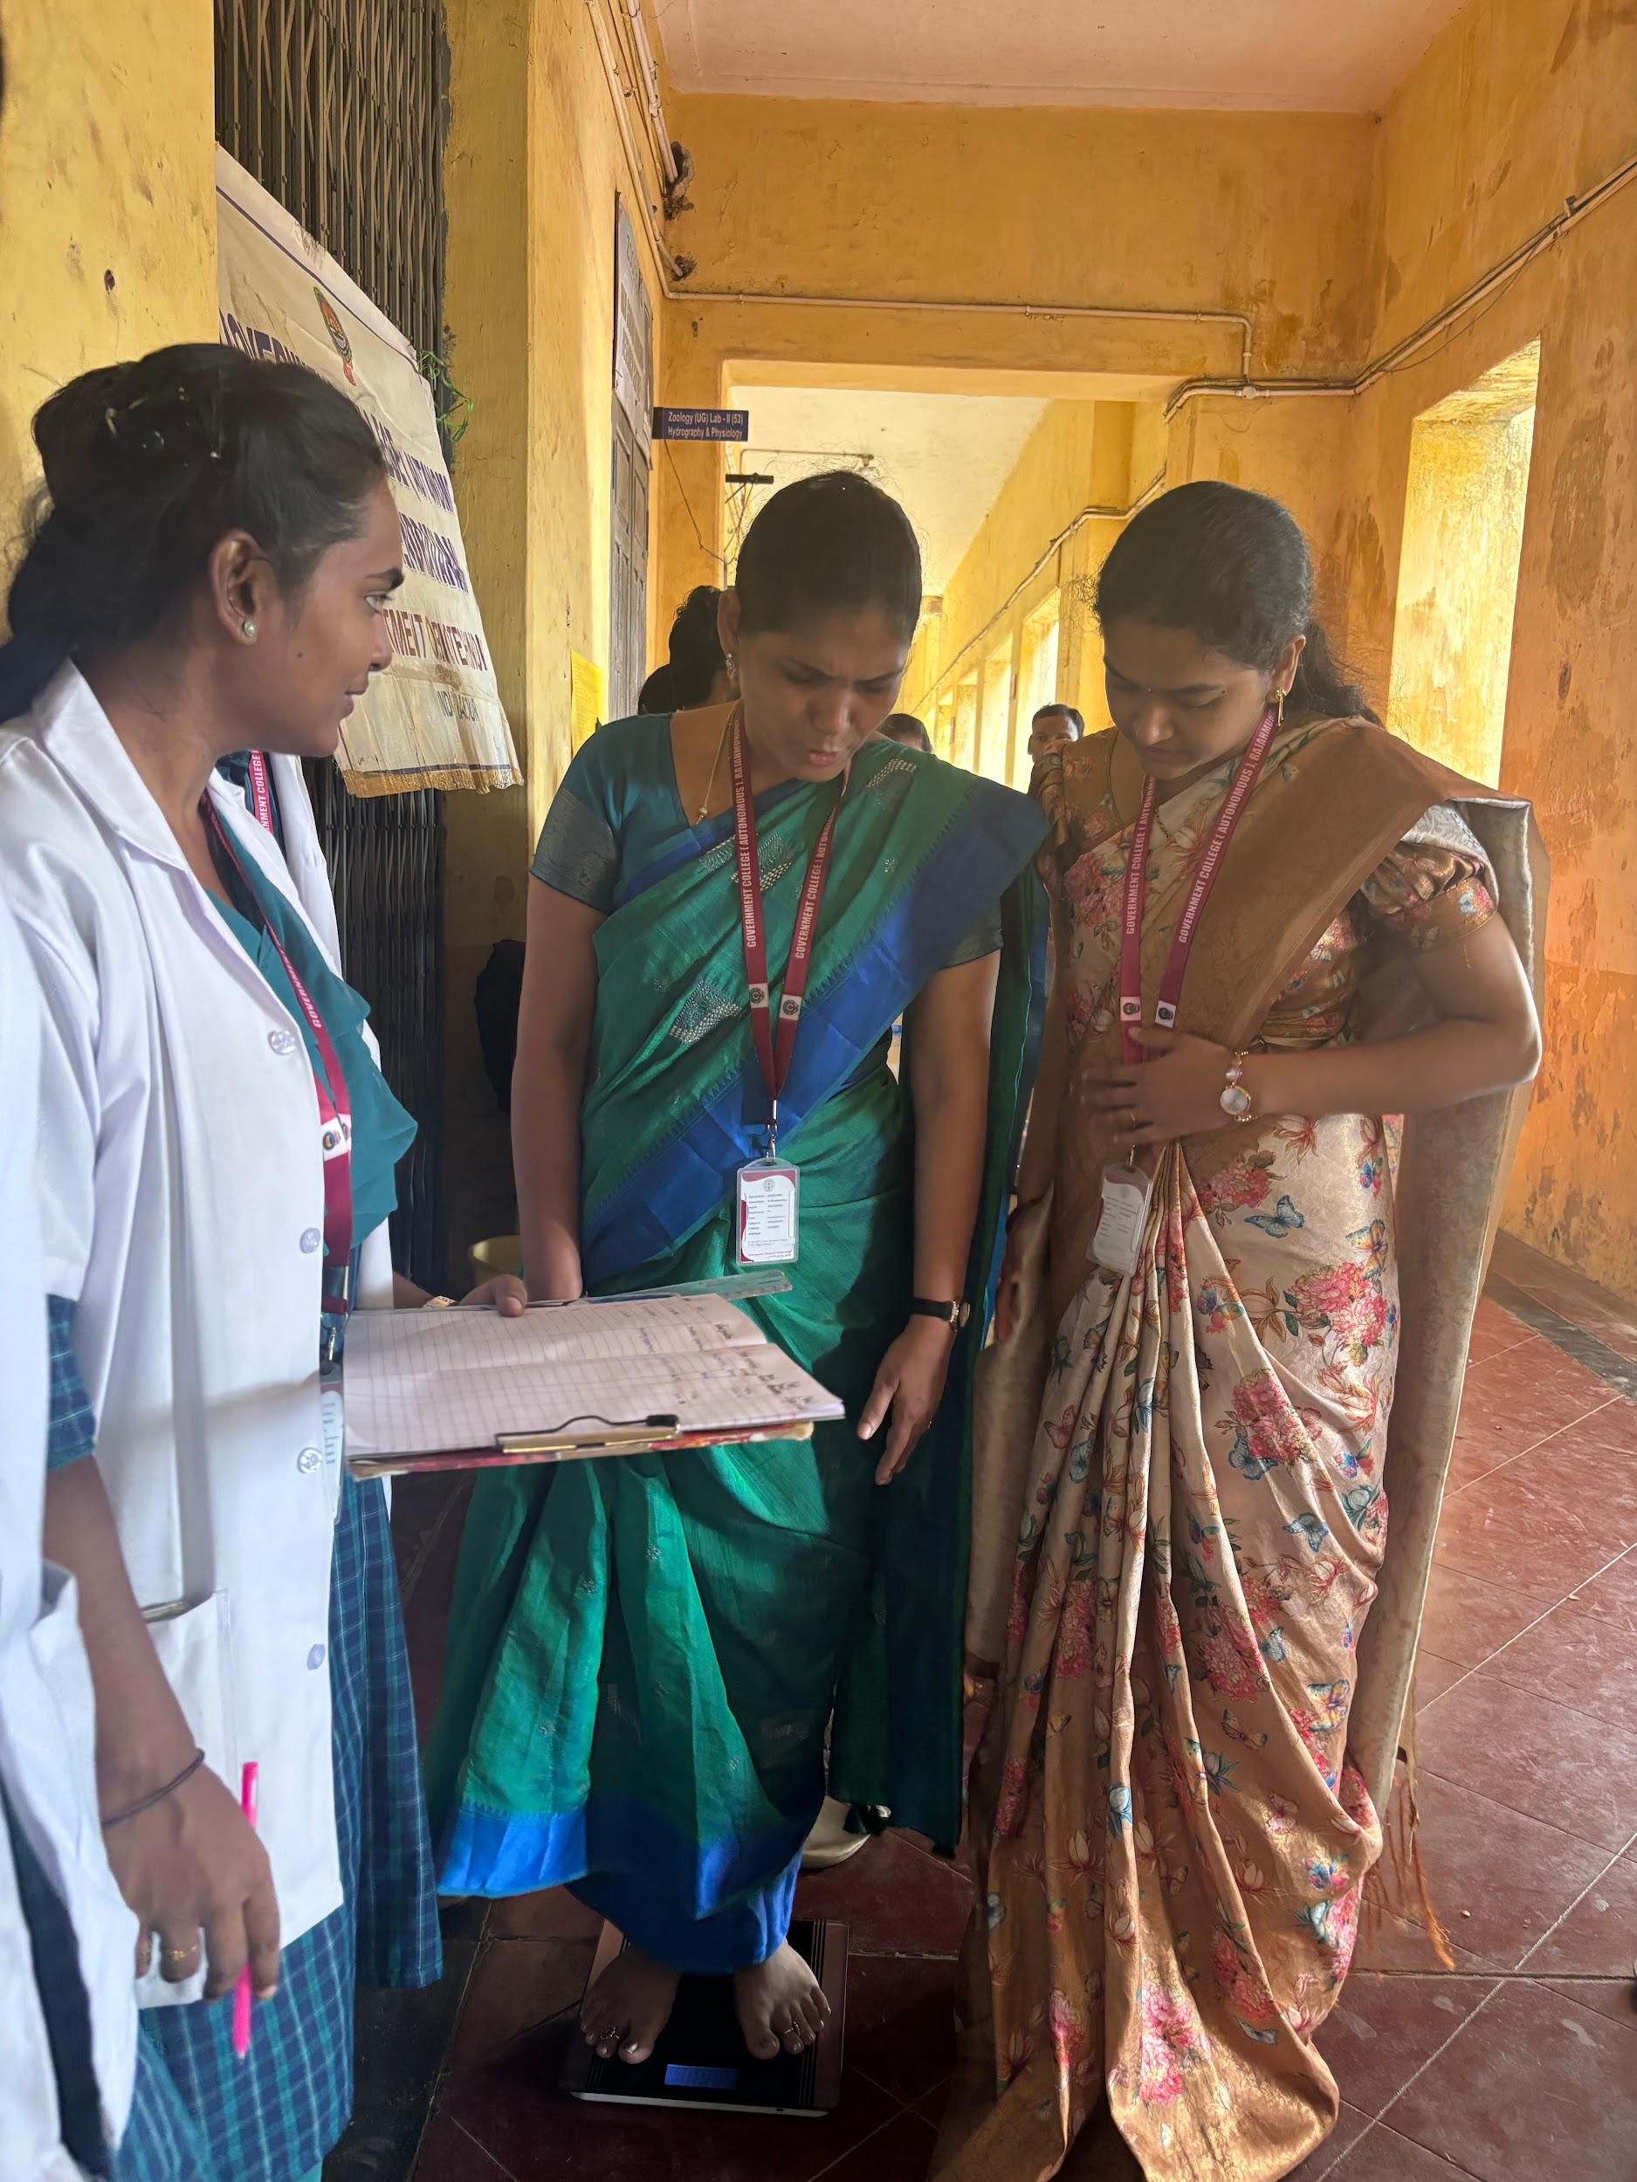

Screening for Diabetes
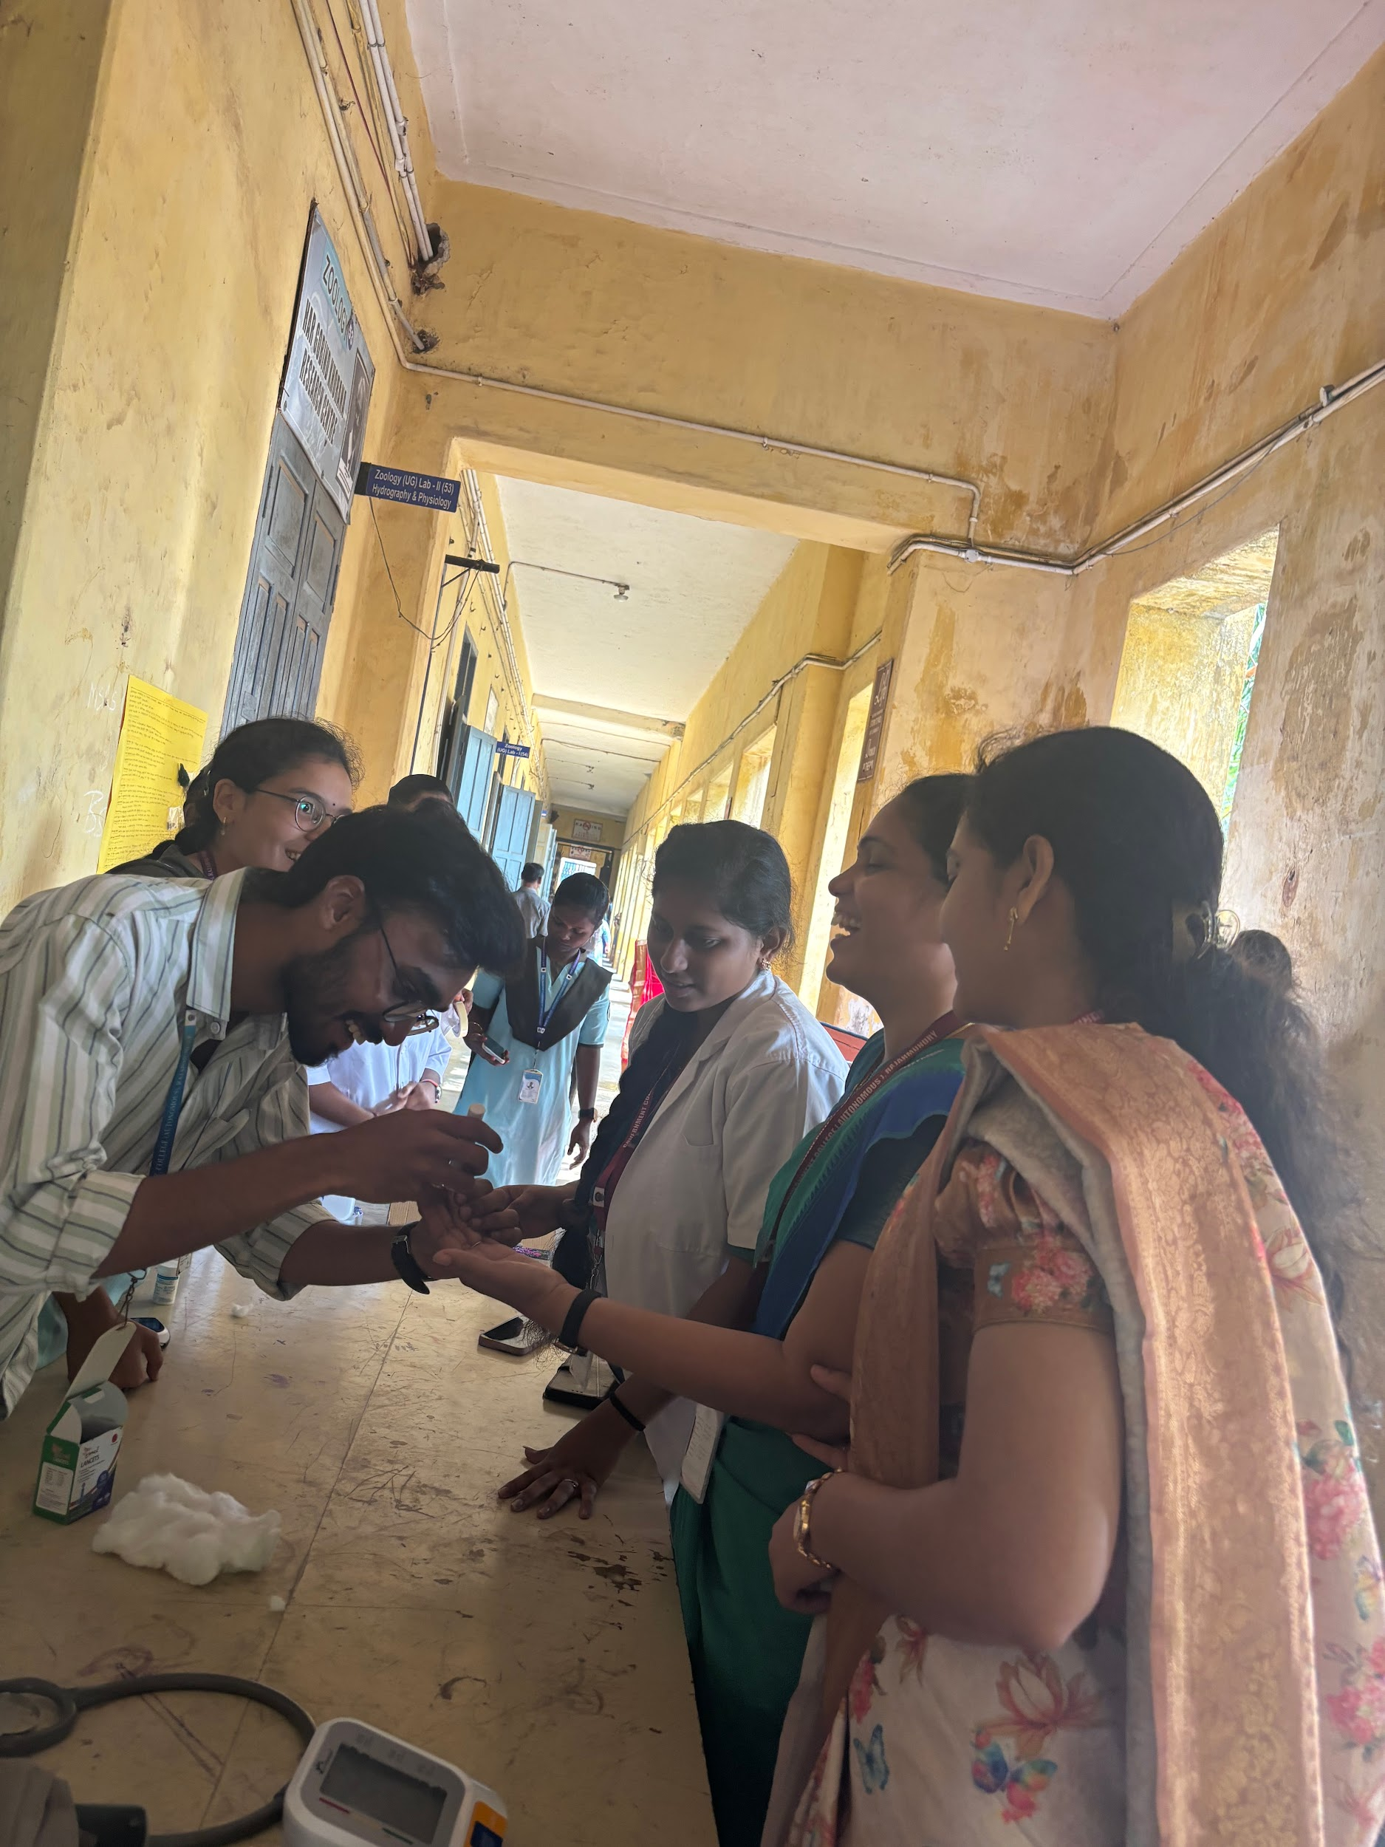

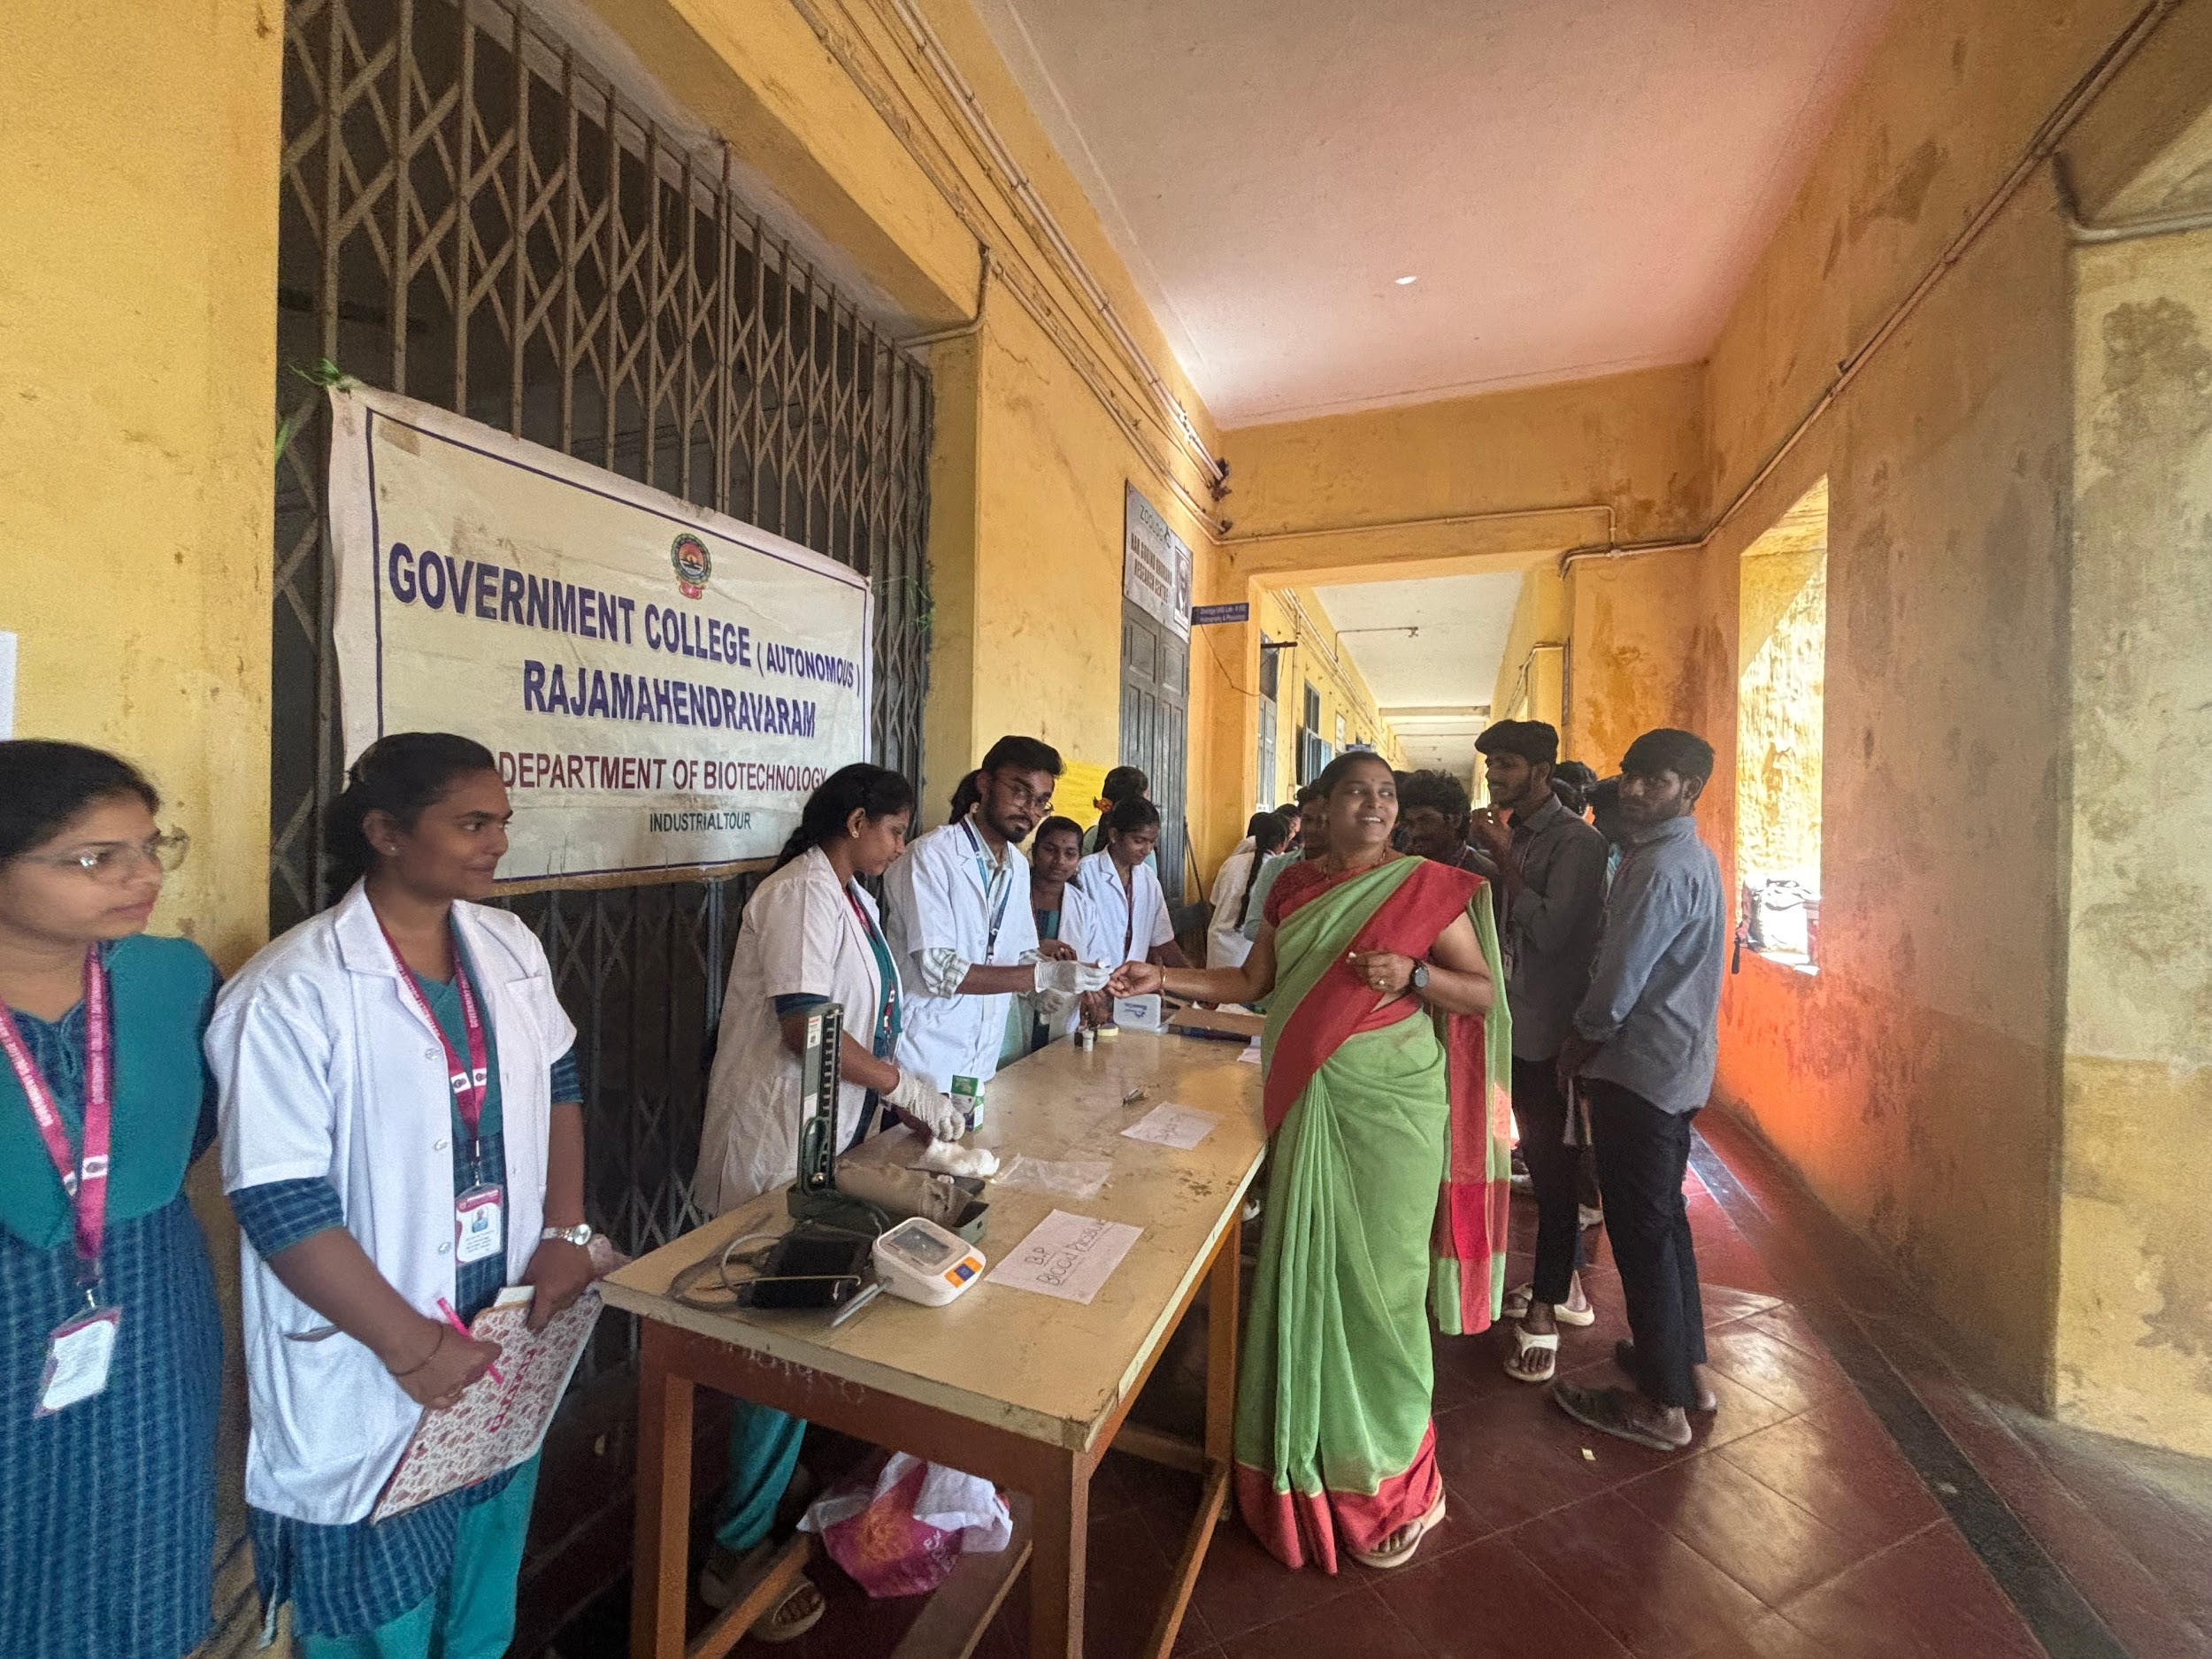

Determination of Blood Grouping
